TRINITY LUTHERAN - FIRST PRESBYTERIAN - ST. MICHAEL EPISCOPAL CHURCHES
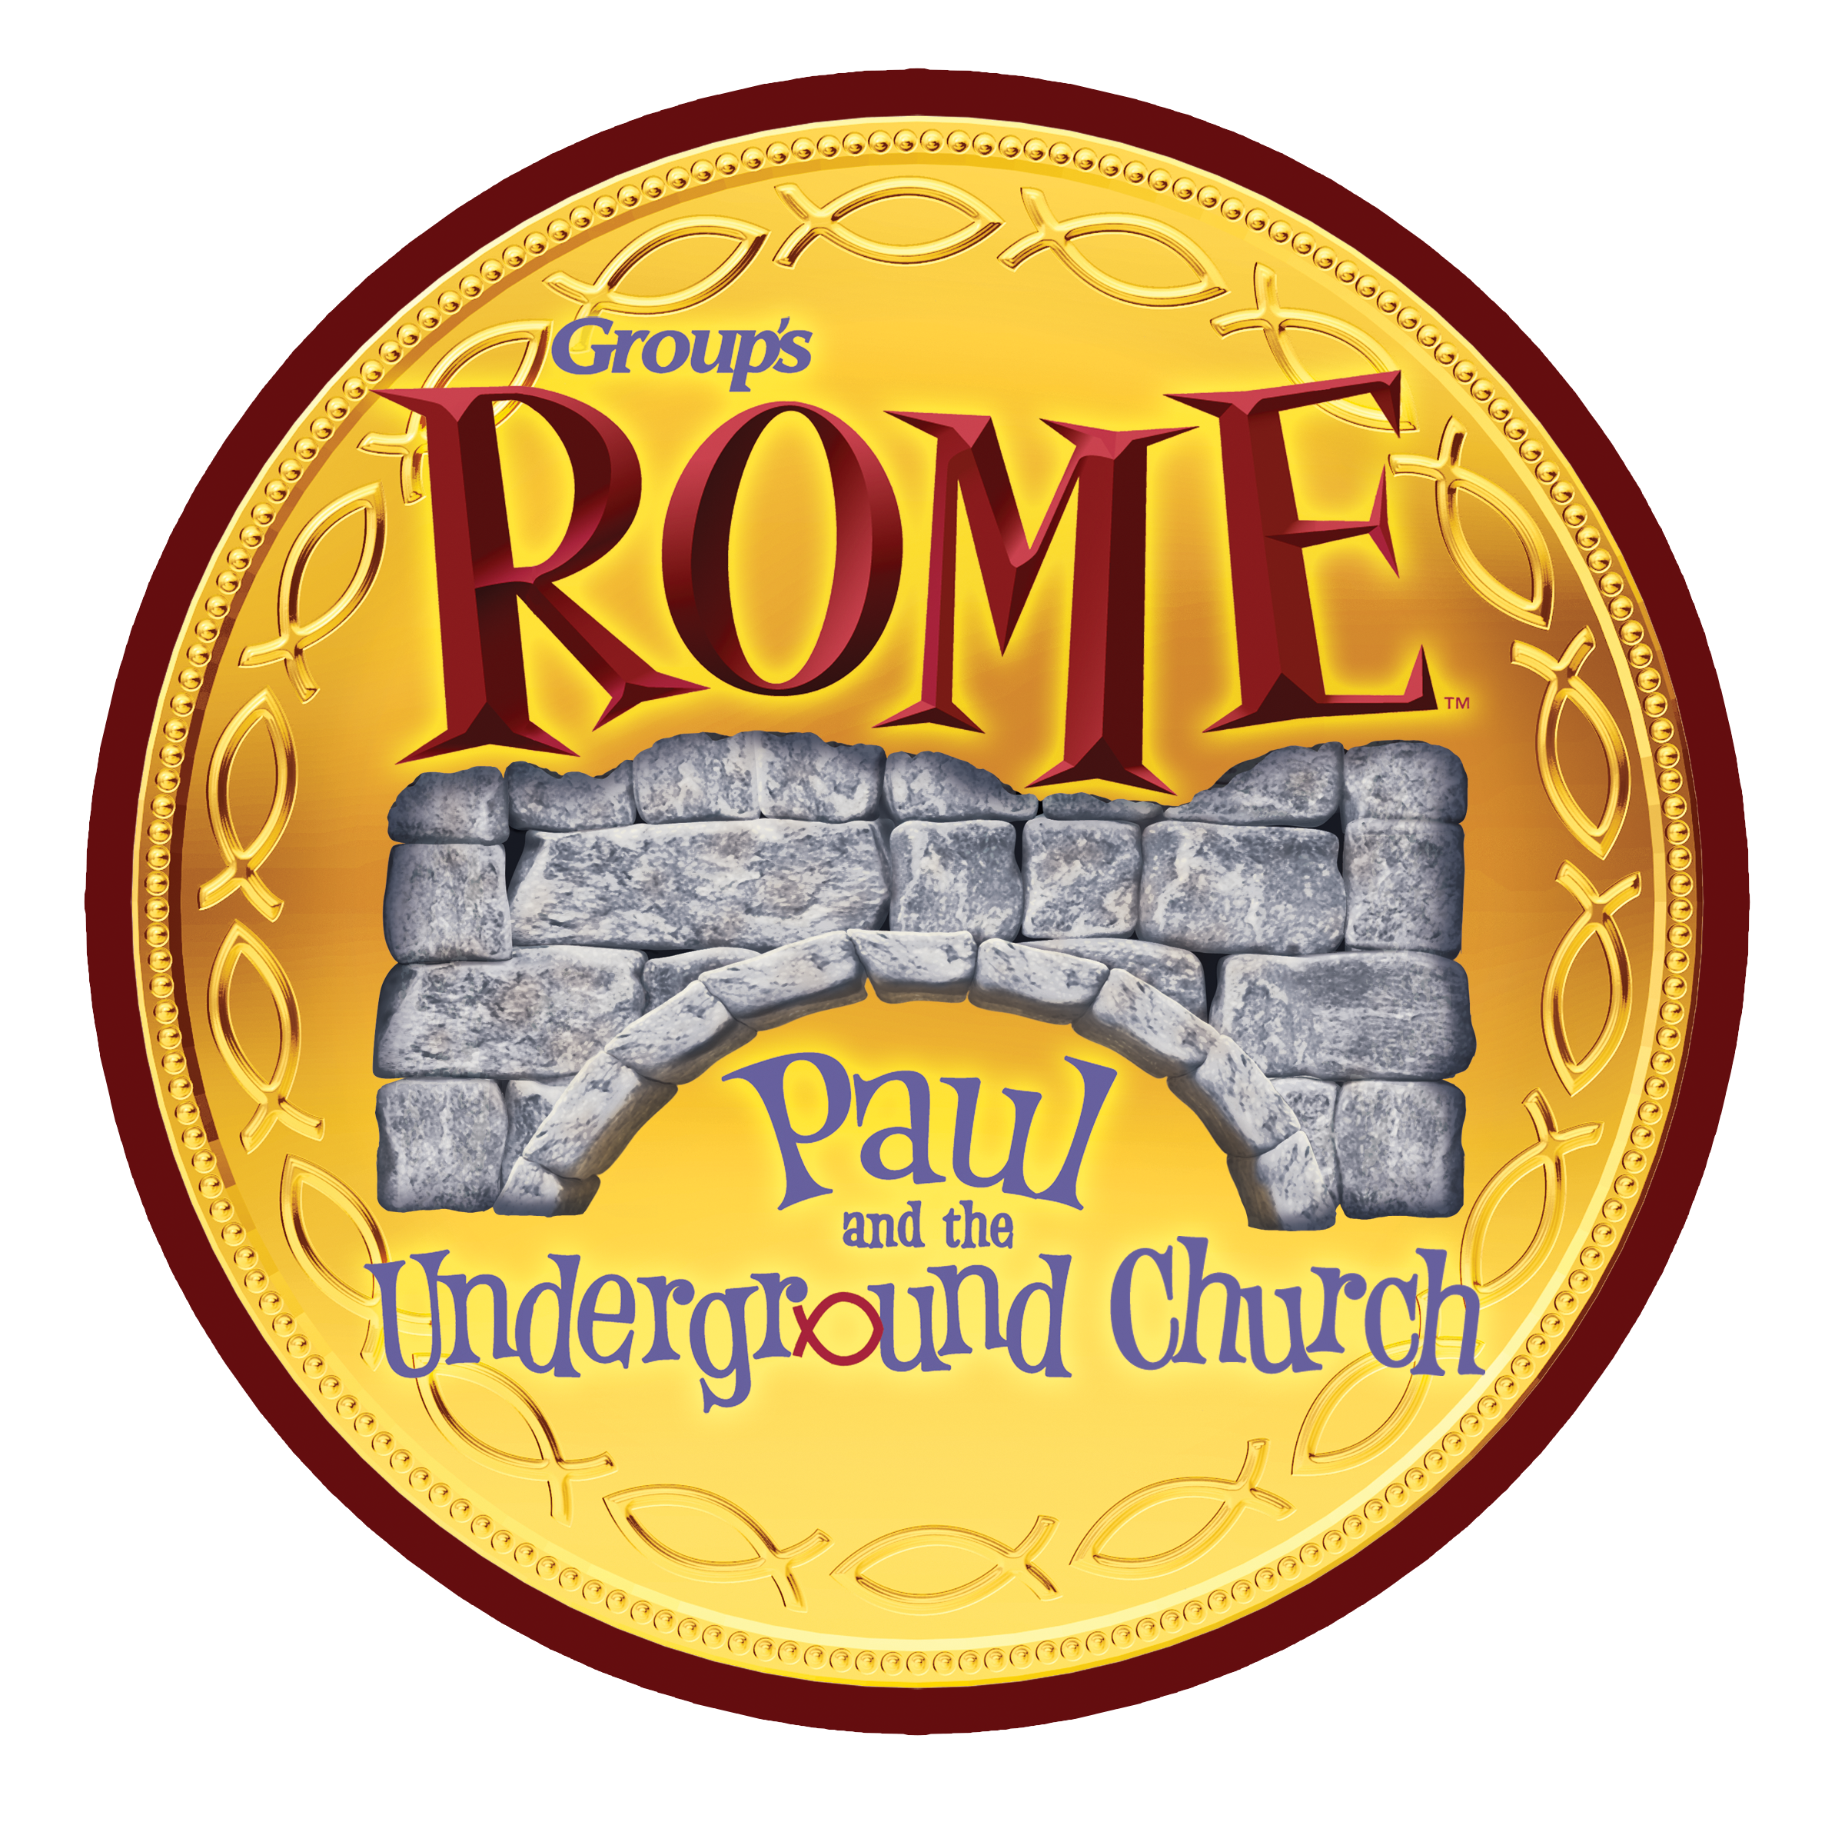
VACATION BIBLE SCHOOL REGISTRATION
June 19-22, 2017 , 5:30-7:30 p.m.
*Student First Name:
*Student Last Name:
Nick Name:
Age:
Gender: Male Female
Grade finished:
T Shirt Size (youth):
Home Church (if applicable):
Allergies:
Medical Issues or special Needs:
*Parent Name:
*Address:
*City:
*State:
*Zip: *Email:
*Home Phone Number:
Cell Phone Number:
Other Phone Number:
Emergency Contact:
Emergency Phone:
Alternate Pickup Name:
Alternate Pickup Phone:
Medical Release: I give my permission for the VBS staff to administer basic first aid to my child (named above) in the event of an injury. I understand that the VBS staff will contact emergency services in the event of a significant injury and
all expenses for such emergency services will be paid by me. Parent's initials (
Photo Release: I hereby grant the above named churches permission to copyright and use photographs/videos taken at VBS of the minor designated above in any manner or form for any purpose lawful at any time. I waive any right that I may have to inspect or approve the finished product or written copy, that may be used in conjunction therewith, or the
use to which it may be applied. Parent's initials (
Permission to Attend: I give permission for my child (named above) to attend the Vacation Bible School (VBS) listed above. I understand that the information I give for this registration will only be used by the VBS hosting churches.
Please return this form to Trinity Lutheran Church, 620 E. Redwood Ave., Fort Bragg, Ca. 95437 or First Presbyterian Church, 360 S. Sanderson Way, Fort Bragg, Ca. 95437 or St. Michael & All Angels Episcopal Church, 201 E. Fir St., Fort Bragg, Ca. 95437 by June 10, 2016.
Parent Signature

